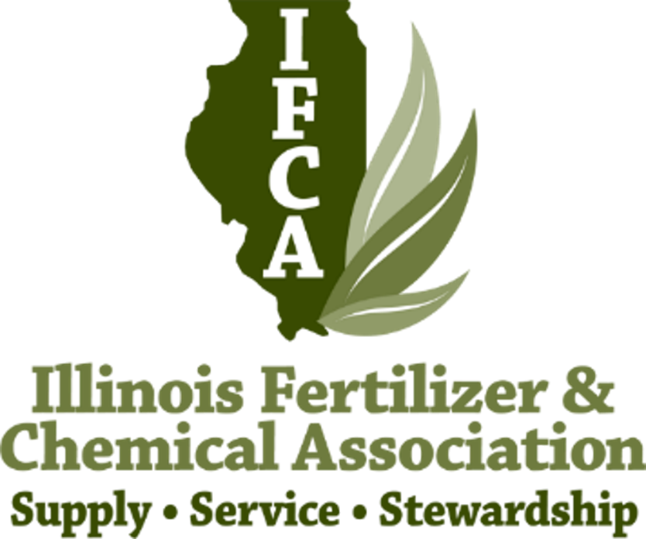

Illinois Fertilizer
&
Chemical Association

Scholarship Application
$1000.00

Return by December 16, 2022 to:

IFCA
14171 Carole Drive
Bloomington, IL 61705
Ph (309) 827-2774
Or email to: jason@ifca.com

Academic Year 2022-2023

Student Name:

Address to Best Reach You:

City STATE_________ ZIP:

Phone Number: Email:

College/University attending: Current GPA ________________
Academic Major/Minor: Expected date of Graduation:

Total College Credit Hours for your curriculum as of end of last completed semester:

Percentage of College expenses provided by:

Parents Loan________________ Off or on Campus Job__________

Merit Scholarship______________ Summer Jobs__________ Other_______________________

Need-based scholarship Savings______________

High School Attended: State

Parents/Guardians:

Hometown of Parents/Guardian:
1. How do you envision using your degree after completing your education?

2. What are your goals and purpose in pursuing a career in agriculture?

3. list clubs, organizations, community activities or other activities or responsibilities you have had:
4. List any employment positions you have held in an agricultural-related field:

(Use a separate sheet of paper if necessary)

